Assessment Schedule – 2014

Chemistry: Demonstrate understanding of equilibrium principles in aqueous systems (91392)

Evidence Statement
Q | Evidence | Achievement | Achievement with Merit | Achievement with Excellence
ONE  (a)(i)  (ii) | HOCl + H₂O ⇌ OCl– + H₃O⁺  HOCl > H₃O⁺ > OCl– > OH– or HOCl > H₃O⁺ = OCl– > OH–  HOCl partially dissociates, and so the equilibrium lies to the LHS/favours the reactants; therefore HOCl is present in the greatest amounts.  H₃O⁺ and OCl– are produced in equal amounts / there is a small contribution to H₃O⁺ from water therefore H₃O⁺ > OCl–  Because there is a relatively high [H₃O⁺], the [OH–] is very low (or links to K_{w}). | - Equation correct.  OR  FOUR species correctly identified.  - Recognises HOCl partially dissociates.  OR  One correct justification.  - Any two correct relationships. | - ALL species and order correct AND partial explanation to support the order of the species.  - Complete comparison. | - ALL species and order correct AND complete justification.
(b) | Hydrofluoric acid is a stronger acid/more acidic/dissociates more because it has a smaller pK_{a} (larger K_{a}) than hypochlorous acid.  So HF will therefore have a higher [H₃O⁺]. As [H₃O⁺] increases, the pH decreases, so HF will have a lower pH than HOCl.  (pH HF = 2.09, HOCl = 4.27) |  |  | - ALL species and order correct AND complete justification.
(c) | 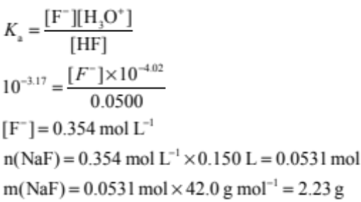 | - Writes correct K_{a} or pH expression.  OR  Calculates K_{a} or [H₃O⁺].  - Correct ‘n’ and ‘m’ step with incorrect [F¯]. | - Correct method but error in calculation / units missing / unit incorrect. | - Correct answer with units.

NØ |  | N1 | N2 | A3 |  | A4 | M5 |  | M6 | E7 |  | E8
No response or no relevant evidence. |  | 1a | 2a | 3a |  | 4a | 2m |  | 3m | 2e with minor error / omission. |  | 2e
Q | Evidence |  |  |  | Achievement |  |  | Achievement with Merit |  |  | Achievement with Excellence
TWO  (a)(i)  (ii)  (iii) | PbCl₂(s) ⇌ Pb²⁺(aq) + 2Cl–(aq)  K_{s} = [Pb²⁺][Cl–]² |  |  |  | - Both (i) and (ii) correct.  - Method correct, for calculation of solubility.  - One calculation step correct.  - Compares incorrect Q and K_{s} to make a valid conclusion. |  |  | - Correct answer for solubility and both [Pb²⁺] and [Cl–].  - One calculation error AND Compares Q and K_{s} to make a valid conclusion. |  |  | - Answer correct with supporting calculation and correct conclusion.
TWO  (a)(i)  (ii)  (iii) | [Pb²⁺] = x [Cl–] = 2x  K_{s} = 4x³  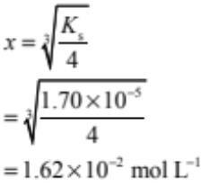  [Pb²⁺] = 1.62 × 10^{–2} mol L^{–1}  [Cl–] = 3.24 × 10^{–2} mol L^{–1}
(b) | n(Pb(NO₃)₂) = 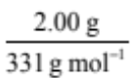  = 6.04 × 10^{–3} mol  ∴[Pb²⁺] = 6.04 × 10^{–3} mol / 0.500L  = 1.21 × 10^{–2} mol L^{–1}  Q = (1.21 × 10^{–2}) x (0.440)²  = 2.34 × 10^{–3}  As Q > K_{s}, a precipitate will form.
(c) | Zn(OH)₂(s) ⇌ Zn²⁺(aq) + 2OH–(aq)  When pH is less than 4 / low, [OH–] is decreased due to the reaction with H₃O⁺ to form water,  H₃O⁺ + OH– → H₂O  so equilibrium shifts to the right to produce more [OH–], therefore more Zn(OH)₂ will dissolve.  When pH is greater than 10 / high, then more OH– is available and the complex ion (zincate ion) will form.  Zn(OH)₂(s)+ 2OH– → [Zn(OH)₄]^{2–}  OR Zn²⁺ + 4OH– → [Zn(OH)₄]^{2–}  This decrease in [Zn²⁺] causes the position of equilibrium to shift further to the right, therefore more Zn(OH)₂ dissolves. |  |  |  | - Writes the equilibrium equation.  - Recognises solubility increases at pH of less than 4 (acidic conditions) due to removal of OH–.  OR  Recognises the solubility increases at a pH greater than 10 due to formation of a complex ion. |  |  | - Partial explanation for BOTH changes in pH, not fully related to the effect on the equilibrium.  OR  One change in pH fully explained. |  |  | - Complete explanation for BOTH changes in pH.

NØ | N1 | N2 | A3 | A4 | M5 | M6 | E7 | E8
No response or no relevant evidence. | 1a | 2a | 3a | 4a | 2m | 3m | 2e with minor error / omission. | 2e

Q | Evidence | Achievement | Achievement with Merit | Achievement with Excellence
THREE  (a) | At point A, [CH₃NH₂] ≈ [CH₃NH₃⁺]. So the solution has buffering properties in the proximity of point A. When HBr is added, the H₃O⁺ is consumed:  H₃O⁺ + CH₃NH₂ → CH₃NH₃⁺ + H₂O  Since the H₃O⁺ is removed from the solution (neutralised), the pH does not change significantly. | - Recognises near point A solution is a buffer /  [CH₃NH₂] ≈ [CH₃NH₃⁺].  - Identifies H₃O⁺ or HBr is neutralised / removed by CH₃NH₂.  - Calculates [OH–] / [H₃O⁺] / K_{b}  - Uses suitable process with more than one error.  OR  Rearranges K_{b} / K_{a} expression so [CH₃NH₂] is the subject. | - Correct equation linked to neutralisation / absorption of H₃O⁺.  - Correct method but an error in the calculation. | - Correct answer with a clear method.
(b) | [H₃O⁺] = 10^{–11.8} = 1.58 x 10⁻¹²  K_{a} = 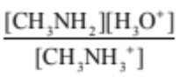  = 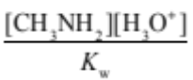  [OH⁻]  2.29 × 10^{–11} = 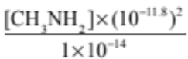  [CH₃NH₂] = 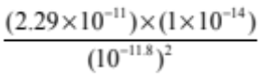  = 0.0912 mol L^{–1}  OR  [OH–] = 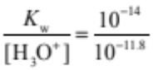  = 6.31 × 10^{–3} mol L^{–1}  K_{b} = 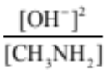  4.37 × 10^{–4} = 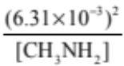  [CH₃NH₂] = 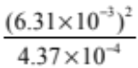  [CH₃NH₂] = 0.0912 mol L^{–1} |  |  | - Correct answer with a clear method.
(c)(i)  (ii) | CH₃NH₃⁺, Br–, CH₃NH₂, H₃O⁺ | TWO OF:  - ALL species correct.  - Recognises ions are required for electrical conductivity in a solution.  - One correct equation. | - Full explanation of the electrical conductivity and species present of either the initial CH₃NH₂ solution or the solution at point B.  OR  for an answer discussing each solution separately:  TWO OF:  Species and comparative concentrations within each solution for both solutions / two of the three equations / conductivity of each solution with reasons. | - Compares and contrasts the electrical conductivity of BOTH the initial CH₃NH₂ solution and the solution at point B, including a consideration of the differing concentrations of each solution.
(c)(i)  (ii) | At the start, before addition of HBr there is a solution of weak base (CH₃NH₂) which only partially reacts with water to produce a relatively low concentration of ions.  As a result, the initial CH₃NH₂ solution will be a poor electrical conductor.  CH₃NH₂ + H₂O ⇌ CH₃NH₃⁺ + OH⁻  Therefore species present are CH₃NH₂ > OH– ≥ CH₃NH₃⁺ > H₃O⁺  At point B, there is a solution of the salt CH₃NH₃Br present which is dissociated completely into ions. Therefore there is a relatively high concentration of ions (CH₃NH₃⁺ and Br–) present in the solution, so it will be a good electrical conductor / electrolyte.  CH₃NH₃Br → CH₃NH₃⁺ + Br–  CH₃NH₃⁺ reacts with water according to the equation  CH₃NH₃⁺ + H₂O ⇌ CH₃NH₂ + H₃O⁺  Species present are Br– > CH₃NH₃⁺ > H₃O⁺ ≥ CH₃NH₂ > (OH–)

NØ | N1 | N2 | A3 | A4 | M5 | M6 | E7 | E8
No response or no relevant evidence. | 1a | 2a | 3a | 4a | 2m | 3m | 2e with minor error / omission. | 2e

Cut Scores
 | Not Achieved | Achievement | Achievement with Merit | Achievement with Excellence
Score range | 0 – 7 | 8 – 13 | 14 – 18 | 19 – 24

